# Read Me

## StrongNameKey.pfx

When building DocX on a new machine for the first time you need to do the following. Using Explorer, navigate to the folder containing the file StrongNameKey.pfx. Right click on the file an choose “Install PFX”.



Follow the install wizard and when prompted for a password as in the below screenshot, enter “Quvu4rey”.

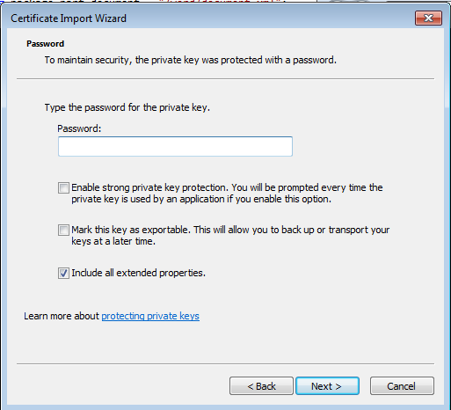

Before you can build DocX you need to exclude and reload StrongNameKey.pfx into your Visual Studio solution.

Exclude the file by right clicking and selecting “Exclude from Project”.

. 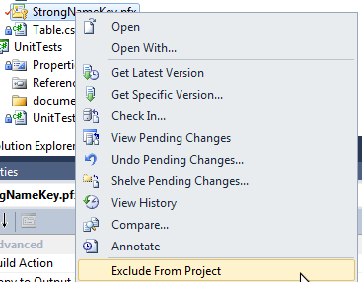

Now simple reinclude the file back into the solution.

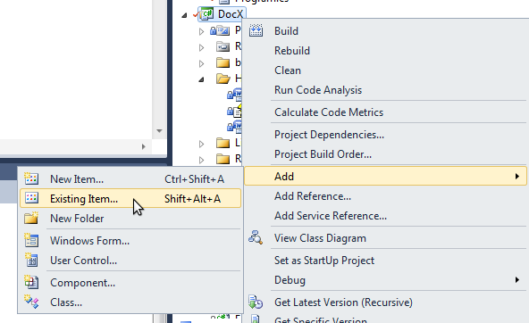

You should now be able to compile DocX successfully.

The .chm documentation  
If on opening the file documentation.chm, you see the message “Navigation to the webpage was cancelled” as depicted in the screenshot below.

[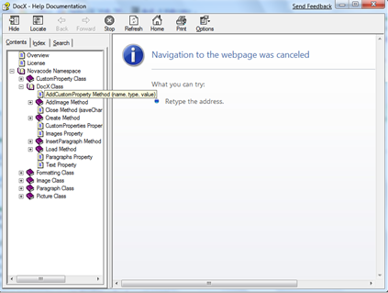](https://u8hm0q.bay.livefilestore.com/y1mVQpow_6gOlABIadJwxz9Two5yyo1jQqf_viaDSnYW9kLz_KDeqJrm4dSErjzR9n9whdbAppFlkGYLg8EH_9JID0BhtaDu7l2zrKXj4E8ZIh8Fq9R9wzQajHi3KItTmfZqU2lJuknpcHtd6b2kPhdFw/image%5b23%5d.png)

Then you need to right click on the .chm file and select properties.

[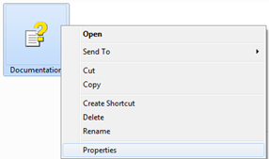](https://u8hm0q.bay.livefilestore.com/y1mTwzy5IFKAKWJa-oJ8kKscTqOfjkQzKSsTzIAUpc6kD9NI8T0WNE1YLa8FoMTxdt2ha63HDQGrv3gz7iv8nFzSnCPLwe51r-Q-Sg5atll1kEC88xLRXe8ypPac32Wq-dniCGVfx2YPF9ZlJ0L1pJu0g/image%5b10%5d%2017A43D77.png)

In the properties window, select unblock, and then press apply followed by ok.

[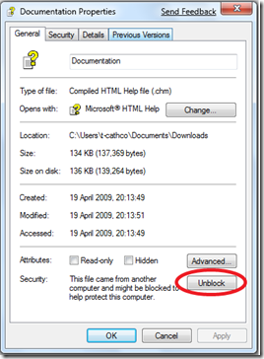](https://u8hm0q.bay.livefilestore.com/y1mhAYHgI8JPEBrC8Pk4dUJWE3kkXLTiZIet7KErfeooejm1XdQzqbNpfd31Q2FecuGdQRYePOBXcMYQbdiqZmYqHLMgJ9Dyd0-mWe4L01VLQZZwDLCKPuQHe2hMa5awOa-0syTx9Tnp4MqiZjQ0cO7KA/image%5b17%5d.png)

You should then be able to view the documentation and it should look similar to the below.

[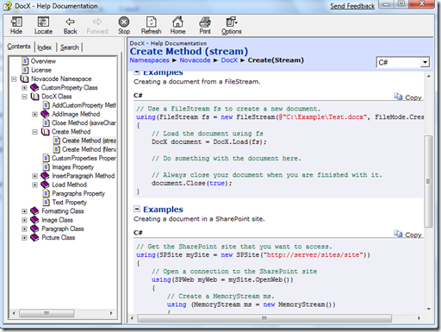](https://u8hm0q.bay.livefilestore.com/y1m7_FETMwVc6vEXb_iWy0SVVDYaAzyLxcA1cFf1FiEco5aT0j5e_hNLX8gCXqLTg7eAmy_Xf2VY9Uqy-a05KWg9j_XvVqI777bRibjyw-e_EJoZMkjf7Wt-WFYUUR1WzKmFjXEIW1Gpd3f4yTjUlLFNQ/image%5b22%5d.png)

The documentation contains lots of examples of how to use all of DocX’s features. If you find a mistake or simply wish to add a code example, please email me. If I think your example adds value to the documentation then I will gladly add it and note your contribution in the credits section.